Get: http://localhost:8080/game/Board/id //id = User.id

returns: Mygame //Object of class Game

class Game:
id //long: the ID of this game
player1id //long: the User.id of player 1 (not neccesarily starting player)
player2id //long: the user.id of player 2
status //String: description of the State of game (e.g. CHOSING_GAME_MODE)
playWithGodCards //boolean: true if the game is to be played with godcards
board //board: object of class board that describes the state of the board
players[2] //an array with two objects of class Player

class Board:
spaces[5][5] //a 5x5 array of objects of class spaces

class spaces:
level //integer: the level of the space (0-3);
dome //bolean:

class Player
myUserID //long: The user.id of this player
startingplayer //boolean: true if this is the starting player
playerNumber //int: information if this is the player 1 or 2 (has nothing to do with starting player)
assignedGod //Godcard: Object of class Godcard (can be NULL)
figurine1 //Figurine: object of class figurine, that belongs to this player
figurine2 //Figurine: object of class figurine, that belongs to this player

class Godcard:
Name: //String: Name of the Godcard
Number: //int: number corresponding to the god in the rules of the game

Figurine:
figrurineNumber //int: 1 or 2, determining the number of this figurine of one player
position[2] //int-array: array with two elements. the first is the row, the second is the column

A few examples on how to use this:
fetch(`${getDomain()}/game/Board/`+ id, {
method: "GET",
headers: {
"Content-Type": "application/json"
}
})
.then(response => response.json())
.then(async game => {
this.setState("board",game.board);
})
.catch(err => {
console.log(err);
alert("Something went wrong getting the game: " + err);
});
somewhere else in this file:<div>
<Spaces>
{this.state.board.map(spaces => {
return (spaces.map( space =>
return (
<SpaceContainer>
if( space.doam ){
drawDoam;
}
</SpaceContainer>
);
)})}
</Users>
This code will probably not compile, since I don‘t relay understand javascript, but I think you get the idea

challenging somebody:

PUT:
URL: {getDomain()}/users/+this.localStorage.getItem("id")
//Where id is my id
Body:
body: JSON.stringify({
challenging: this.state.oponent.id,
})

checking if one is getting challenged somebody:
GET:
URL: {getDomain()}/users/+this.localStorage.getItem("id")
//Where id is my id
Body: -

Store the returned user in this.setState({"myUser": user});
Then you can check: this.state.myUser.gettingChallengedBy != null
If you are beeing challenged, then ‚gettingChallengedBy‘ will contain the id of your challenger

acceptpting a challenge:
PUT
URL: {getDomain()}/users/+this.localStorage.getItem("id")
Body:
body: JSON.stringify({
challenging: this.state.myUser.gettingChallengedBy ,
})

Refusing a challenge;
PUT
URL: {getDomain()}/users/+this.localStorage.getItem("id")
Body:
body: JSON.stringify({
gettingChallengedBy: null ,
})

printsrceens of my Postman:
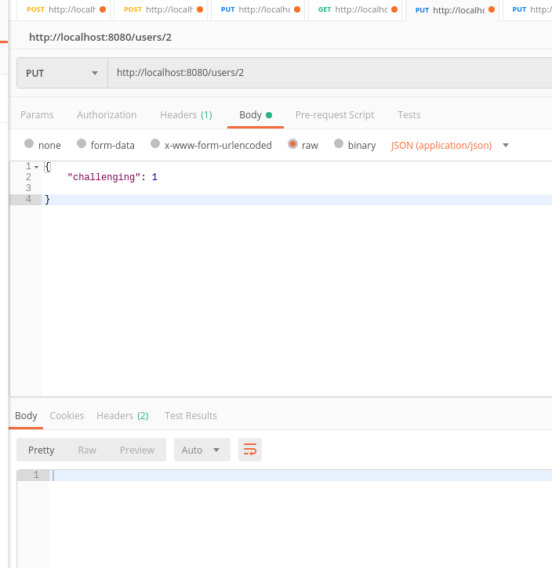Illustration 2: User with ID 2 challenges User with ID 1
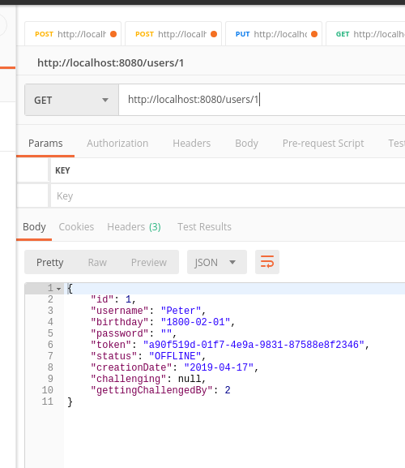Illustration 3: User with ID 1 sees that he has been challenged by User with ID 2
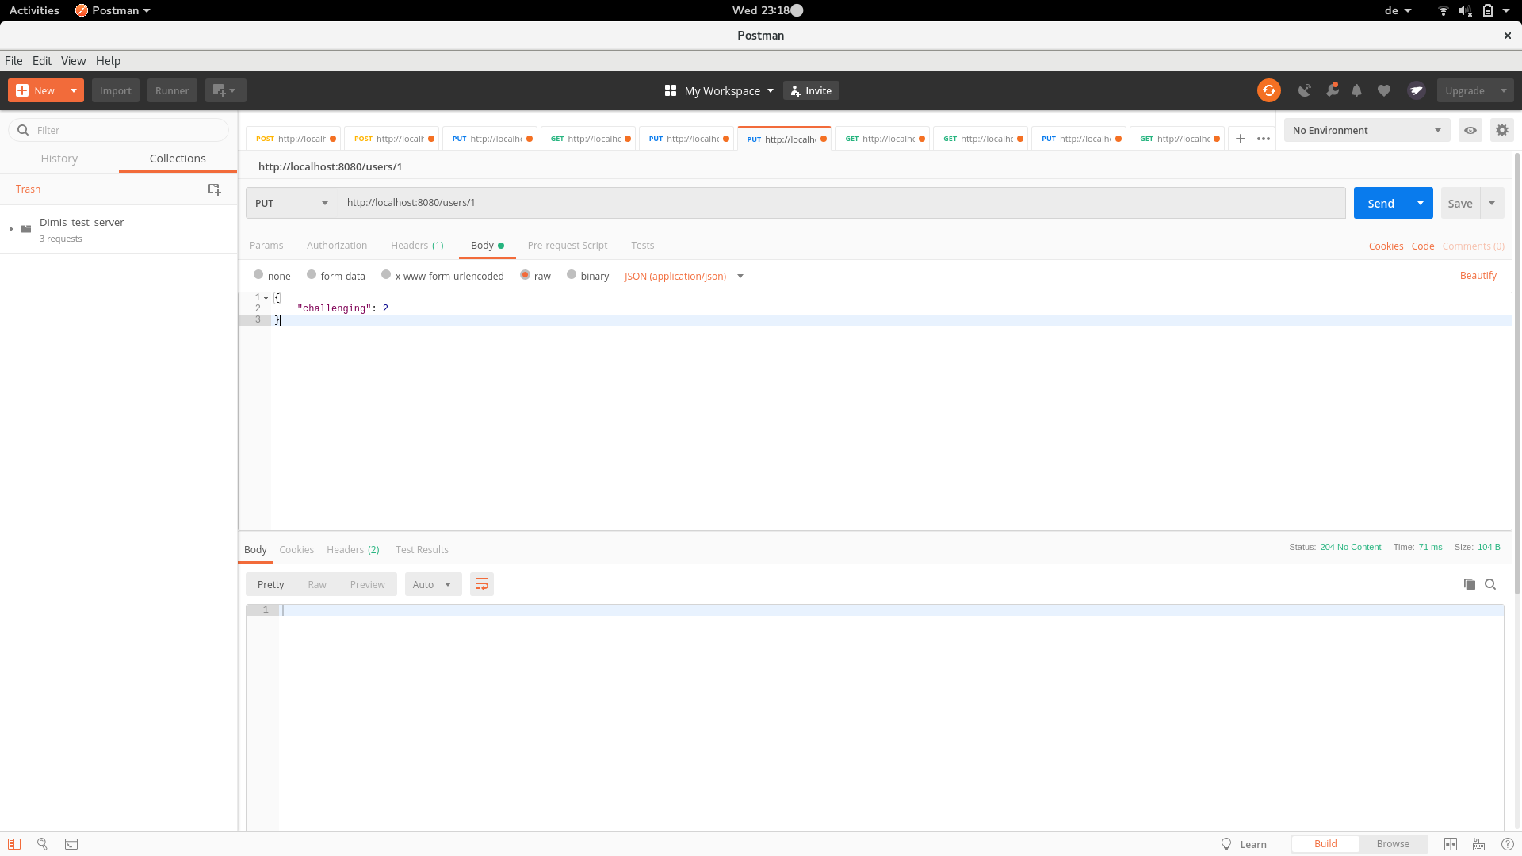Illustration 1: User With ID 1 accepts the challenge of User with ID 2

